



**Batch: B-4 Roll No.: 16010422234 Name: Chandana Ramesh Galgali**

**Experiment No.: 4**

**Title:**  Execution of object relational queries

**___________________________________________________________________________**

**Resources needed:** PostgreSQL 9.3

**___________________________________________________________________________**

**Theory**

Object types are user-defined types that make it possible to model real-world entities such as customers and purchase orders as objects in the database.

New object types can be created from any built-in database types and any previously created object types, object references, and collection types. Metadata for user-defined types is stored in a schema that is available to SQL, PL/SQL, Java, and other published interfaces.

#### Row Objects and Column Objects:

Objects that are stored in complete rows in object tables are called row objects. Objects that are stored as columns of a table in a larger row, or are attributes of other objects, are called column objects

### Defining Types:

In PostgreSQL the syntax for creating simple type is as follows,

**CREATE TYPE name AS ( attribute_name data_type [, ... ] );**

Example:

A definition of a point type consisting of two numbers in PostgreSQL is as follows,

**create type PointType as(**

**x int,**

**y int**

**);**

An object type can be used like any other type in further declarations of object-types or table-types.

E.g. a new type with name LineType is created using PointType which was created earlier.

**CREATE TYPE LineType AS(**

**end1 PointType,**

**end2 PointType**

**);**

### Dropping Types :

To drop type for example LineType, command will be :

**DROP TYPE Linetype;**

### Constructing Object Values:

Like C++, PostgreSQL provides built-in constructors for values of a declared type, and these constructors can be invoked using a parenthesized list of appropriate values.

For example, here is how we would insert into Lines a line with ID 27 that ran from the origin to the point (3,4):

**INSERT INTO Lines VALUES(27,((0,0),(3,4)),distance(0,0,3,4));**

**Declaring and Defining Methods:**

A type declaration can also include methods that are defined on values of that type. The method is declared as shown in the example below.

**CREATE OR REPLACE FUNCTION distance(x1 integer, y1 integer,x2 integer,y2 integer) RETURNS float AS $$**

**BEGIN**

**RETURN sqrt(power((x2-x1),2)+power((y2-y1),2));**

**END;**

**$$ LANGUAGE plpgsql;**

Then you can create tables using these object types and basic data types.

Creation on new table Lines is shown below.

**CREATE TABLE Lines (**

**lineID INT,**

**line LineType,**

**dist float**

**);**

Now after the table is created you can add a populate table by executing insert queries as explained above.

You can execute different queries on the Lines table. For example to display data from the Lines table, select a specific line from the Lines table etc.

### Queries to Relations That Involve User-Defined Types:

Values of components of an object are accessed with the dot notation. We actually saw an example of this notation above, as we found the x-component of point end1 by referring to end1.x, and so on. In general, if *N* refers to some object *O* of type *T*, and one of the components (attribute or method) of type *T* is *A*, then N.A refers to this component of object *O*.

For example, the following query finds the x coordinates of both endpoints of the line.

**SELECT lineID, ((L.line).end1).x,((L.line).end2).x FROM Lines L;**

* Note that in order to access fields of an object, we have to start with an *alias* of a relation name. While lineID, being a top-level attribute of relation Lines, can be referred to normally, in order to get into the attribute line, we need to give relation Lines an alias (we chose L) and use it to start all paths to the desired subobjects.
* Dropping the ``L'' or replacing it by ``Lines.'' doesn't work.
* Notice also the use of a method in a query. Since line is an attribute of type LineType, one can apply to it the methods of that type, using the dot notation shown.
* Here are some other queries about the relation lines.

**SELECT (L.line).end2 FROM Lines L;**

Prints the second end of each line, but as a value of type PointType, not as a pair of numbers.

**Object Oriented features:**

**Inheritance:**

**CREATE TABLE point of PointType;**

**CREATE TABLE axis (**

**z int**

**) inherits (point);**

**INSERT INTO axis values(2,5,6);**

**select * from axis;**

**__________________________________________________________________________**

**Procedure / Approach /Algorithm / Activity Diagram:**

Perform following tasks,

* Create a table using object type field
* Insert values in that table
* Retrieve values from the table
* Implement and use any function associated with the table created

**________________________________________________________________**

**Results: (Queries depicting the above said activity performed individually)**

**create type PointType as(**

**x int,**

**y int**

**);**

**CREATE TYPE LineType AS(**

**end1 PointType,**

**end2 PointType**

**);**

**CREATE OR REPLACE FUNCTION distance(x1 integer, y1 integer,x2 integer,y2 integer) RETURNS float AS $$**

**BEGIN**

**RETURN sqrt(power((x2-x1),2)+power((y2-y1),2));**

**END;**

**$$ LANGUAGE plpgsql;**

**CREATE TABLE Lines (**

**lineID INT,**

**line LineType,**

**dist float**

**);**

**INSERT INTO Lines VALUES(27,((0,0),(3,4)),distance(0,0,3,4));**

**SELECT lineID, ((L.line).end1).x,((L.line).end2).x FROM Lines L;**

**SELECT (L.line).end2 FROM Lines L;**

**CREATE TABLE point of PointType;**

**CREATE TABLE axis (**

**z int**

**) inherits (point);**

**INSERT INTO axis values(2,5,6);**

**select * from axis;**

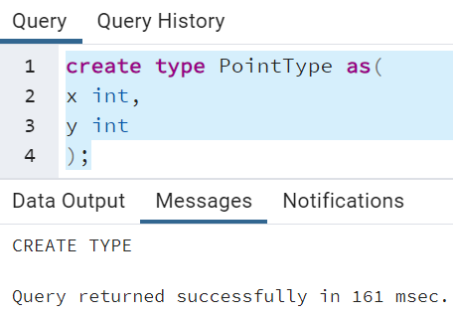

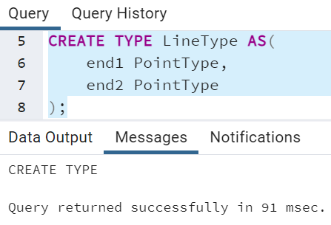

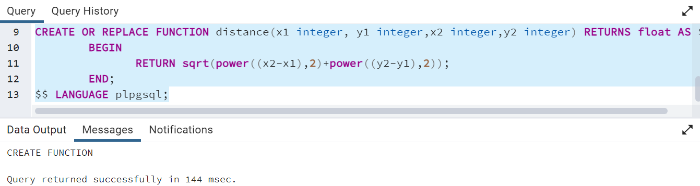

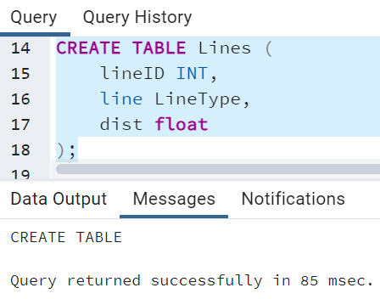

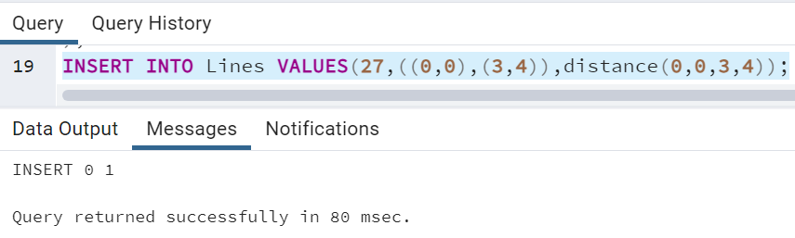

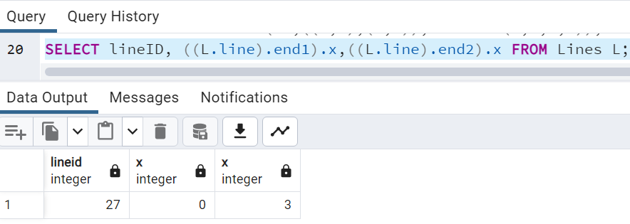

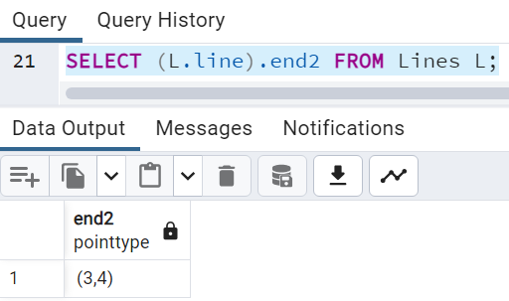

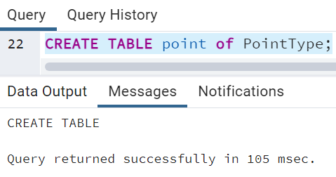

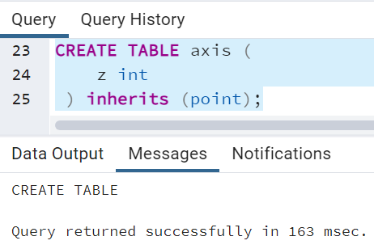

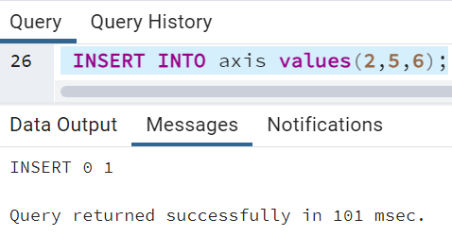

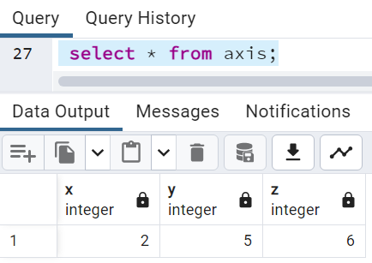

**Queries:**

**CREATE TYPE CustomerType AS (**

**customerID INT,**

**firstName VARCHAR(50),**

**lastName VARCHAR(50),**

**accountNumber VARCHAR(15)**

**);**

**CREATE TYPE TransactionType AS (**

**transactionID INT,**

**transactionDate TIMESTAMP,**

**amount DECIMAL(10, 2),**

**description VARCHAR(255)**

**);**

**CREATE OR REPLACE FUNCTION calculateBalance(p_accountNumber VARCHAR(15)) RETURNS DECIMAL AS $$**

**DECLARE**

**totalAmount DECIMAL(10, 2);**

**BEGIN**

**SELECT COALESCE(SUM((t.transactionData).amount), 0)**

**INTO totalAmount**

**FROM Transactions t**

**WHERE t.accountNumber = p_accountNumber;**

**RETURN totalAmount;**

**END;**

**$$ LANGUAGE plpgsql;**

**CREATE TABLE Customers (**

**customerID SERIAL PRIMARY KEY,**

**customerData CustomerType**

**);**

**CREATE TABLE Transactions (**

**transactionID SERIAL PRIMARY KEY,**

**transactionData TransactionType,**

**accountNumber VARCHAR(15)**

**);**

**INSERT INTO Customers (customerData) VALUES**

**((1, 'John', 'Doe', 'ACC123')),**

**((2, 'Jane', 'Smith', 'ACC456'));**

**INSERT INTO Transactions (transactionData, accountNumber) VALUES**

**((1, '2024-01-23 10:30:00', 100.00, 'Deposit'), 'ACC123'),**

**((2, '2024-01-23 11:45:00', -50.00, 'Withdrawal'), 'ACC123'),**

**((3, '2024-01-23 12:15:00', 200.00, 'Deposit'), 'ACC456');**

**SELECT c.customerID, (c.customerData).firstName, (c.customerData).lastName, calculateBalance((c.customerData).accountNumber) AS balance**

**FROM Customers c;**

**Output(s):**

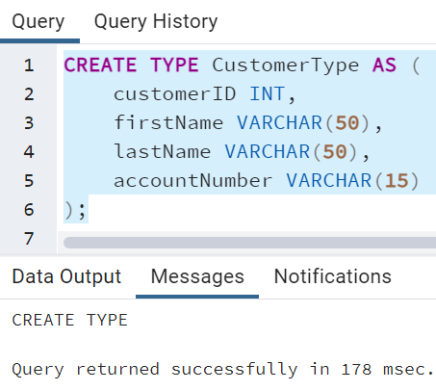

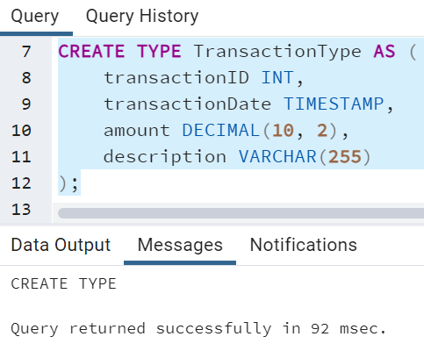

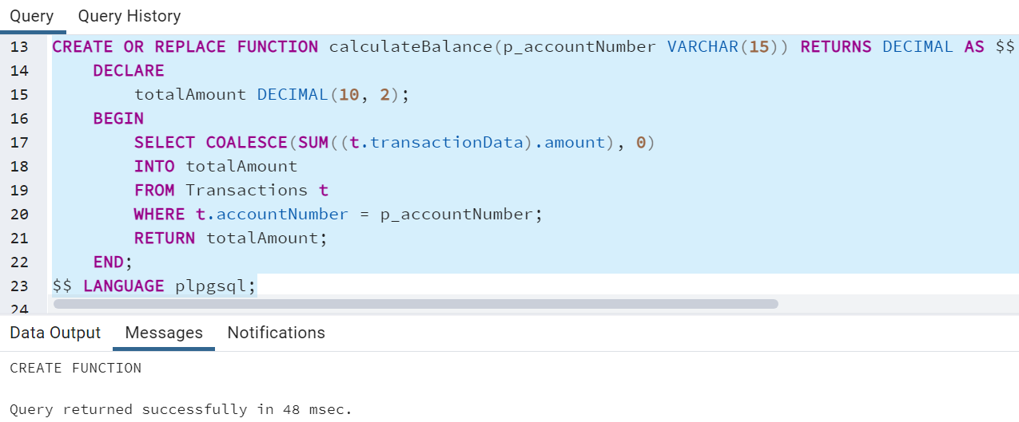

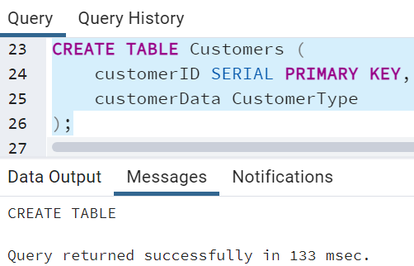

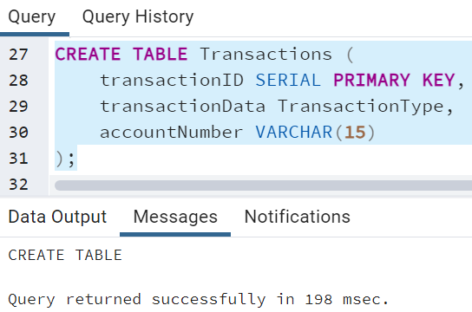

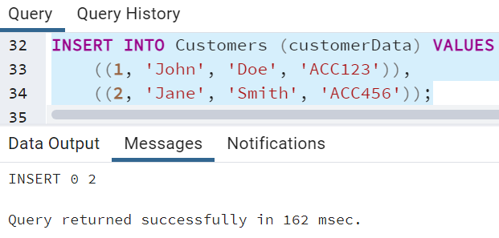

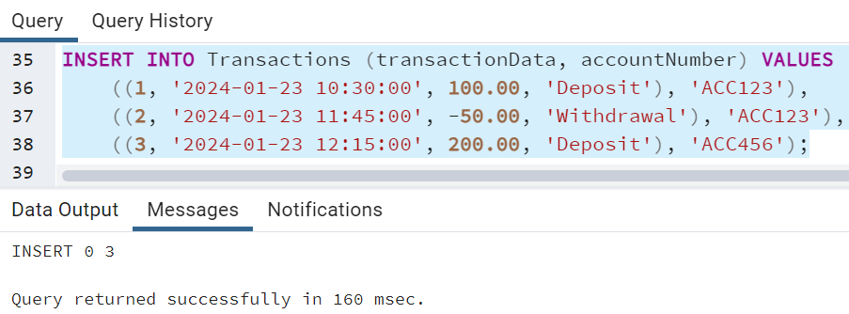

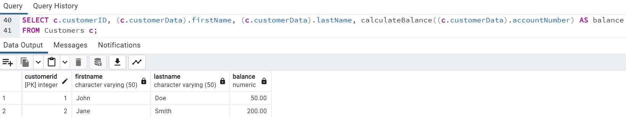

___________________________________________________________________________

**Questions:**

1. **What is the difference between object relational and object oriented databases?**

**Ans:** Object Relational Databases (ORD):

* Structure: ORD combines features of relational databases with object-oriented database capabilities.
* Data Modeling: Tables are used for data storage, but they can contain complex data types and support relationships similar to object-oriented models.
* Flexibility: Offers more flexibility than traditional relational databases, allowing users to define complex data types and structures.
* SQL: Supports SQL for querying and manipulating data, often with extensions to handle complex data types.

Example: PostgreSQL with its support for user-defined types and object-oriented features.

Object Oriented Databases (OODB):

* Structure: OODBs store data in the form of objects, similar to object-oriented programming languages.
* Data Modeling: Objects encapsulate data and behavior, allowing for more natural representation of real-world entities.
* Flexibility: Provides high flexibility in handling complex relationships and supports inheritance and polymorphism.
* Query Language: Uses Object Query Language (OQL) or similar languages for querying, which is more closely aligned with object-oriented concepts.

Example: db4o, ObjectDB.

1. **Give comparison of any two database systems providing object relational database features.**

**Ans:** PostgreSQL (Object Relational Database):

* Model: Combines relational and object-oriented models.
* Data Types: Supports user-defined types, allowing users to create custom data types.
* Query Language: Uses SQL for querying and manipulation.

Example:

**-- Creating a custom type in PostgreSQL**

**CREATE TYPE address AS (street VARCHAR, city VARCHAR, state VARCHAR);**

**-- Creating a table using the custom type**

**CREATE TABLE person (**

**id SERIAL PRIMARY KEY,**

**name VARCHAR,**

**home_address address**

**);**

db4o (Object Oriented Database):

* Model: Purely object-oriented, storing data as objects.
* Data Types: Represents data using objects with attributes and methods.
* Query Language: Utilizes Object Query Language (OQL) for querying.

Example:

**// Storing an object in db4o**

**ObjectContainer db = Db4o.openFile("database.db4o");**

**Person person = new Person("John Doe", new Address("123 Main St", "City", "State"));**

**db.store(person);**

**db.close();**

1. **Explore how the user defined types can be modified with queries.**

**Ans:** Modifying user-defined types typically involves using specific SQL statements to alter the type or updating the instances of the type. For example, in PostgreSQL:

**-- Adding a new attribute to the user-defined type**

**ALTER TYPE address ADD ATTRIBUTE country VARCHAR;**

**-- Modifying an instance of the user-defined type**

**UPDATE person SET home_address.country = 'USA' WHERE id = 1;**

**___________________________________________________________________________**

**Outcomes: Design advanced database systems using Object relational, Spatial and NOSQL databases and its implementation.**

**___________________________________________________________________________**

**Conclusion: (Conclusion to be based on the objectives and outcomes achieved)**

The execution of object-relational queries is a valuable skill in the realm of database management. The experiment successfully achieved its objectives by imparting knowledge on the principles of object-relational databases, facilitating a comparative analysis, and providing practical insights into the execution of queries. This newfound understanding equips individuals with the tools necessary to navigate and manipulate data effectively in object-relational database environments.

**Grade: AA / AB / BB / BC / CC / CD /DD**

**Signature of faculty in-charge with date**

**___________________________________________________________________________**

**References:**

1. Elmasri and Navathe, “Fundamentals of Database Systems”, Pearson Education
2. Raghu Ramakrishnan and Johannes Gehrke, “Database Management Systems” 3rd Edition, McGraw Hill,2002
3. Korth, Silberchatz, Sudarshan, “Database System Concepts” McGraw Hill